TASK 4 – Constructors and Object Initialization
Aim
To understand constructors, the this keyword, constructor chaining, copy constructors, and memory allocation in Java.

1. Types of Constructors
Default Constructor: A constructor without parameters. Java provides a default constructor automatically only when no constructor is defined.
Parameterized Constructor: A constructor that accepts parameters to initialize an object with specific values.
Copy Constructor: A user-defined constructor that creates an object by copying the values of another object of the same class.

2. Java Program
class Vehicle {
String vehicleNo;
String vehicleType;
// Default constructor
Vehicle() {
this("UNKNOWN", "Car");
}
// Parameterized constructor
Vehicle(String vehicleNo, String vehicleType) {
this.vehicleNo = vehicleNo;
this.vehicleType = vehicleType;
}
// Copy constructor
Vehicle(Vehicle v) {
this(v.vehicleNo, v.vehicleType);
}
void display() {
System.out.println("Vehicle No: " + vehicleNo);
System.out.println("Vehicle Type: " + vehicleType);
}
public static void main(String[] args) {
Vehicle v1 = new Vehicle();
Vehicle v2 = new Vehicle("TN01AB1234", "Car");
Vehicle v3 = new Vehicle(v2);
v1.display();
v2.display();
v3.display();
}
}
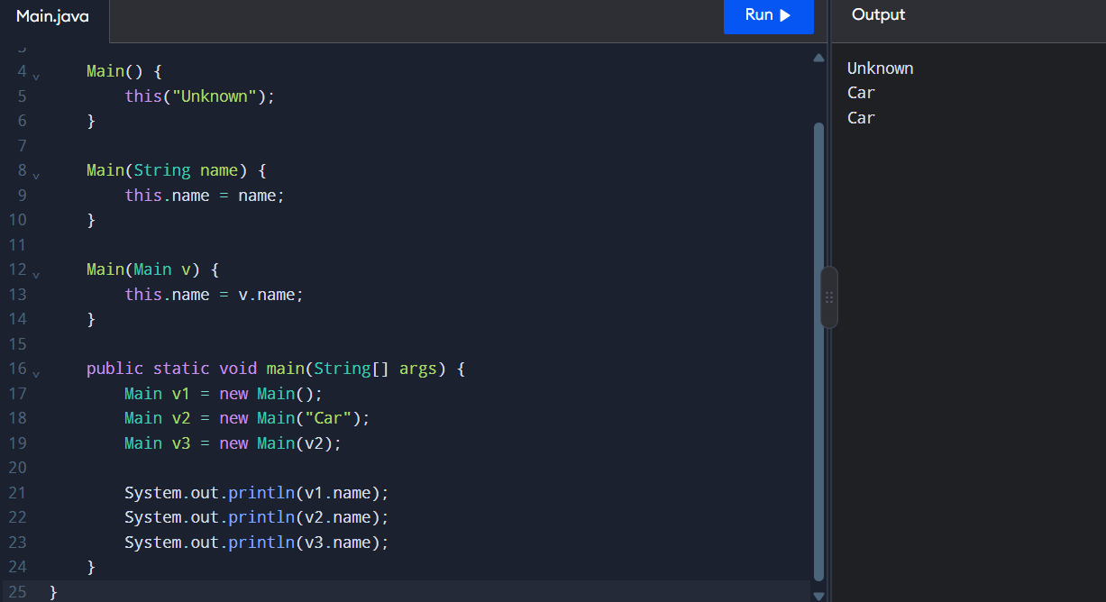
3. Expected Output
Vehicle No: UNKNOWN
Vehicle Type: Car
Vehicle No: TN01AB1234
Vehicle Type: Car
Vehicle No: TN01AB1234
Vehicle Type: Car
4. Explanation of this Keyword
- this.vehicleNo = vehicleNo; refers to the current object's instance variable.
- this("UNKNOWN", "Car"); calls another constructor in the same class.
- Constructor chaining reduces code duplication.
- A call to this() must be the first statement in a constructor.

5. Stack and Heap Memory
- Stack: Stores local variables and references used by method calls.
- Heap: Stores objects created using the new keyword.
- v1, v2, and v3 are reference variables, while their objects are stored in heap memory.
- When an object is no longer reachable, it may be removed by Java's garbage collector.

6. Alternative Constructor Approach
Instead of using a copy constructor, a static factory method can create a copy:
static Vehicle copyOf(Vehicle v) {
return new Vehicle(v.vehicleNo, v.vehicleType);
}
This method can be called using Vehicle.copyOf(v2).

Result
Constructors were implemented successfully using default, parameterized, and copy constructors. The this keyword and constructor chaining were used to initialize objects and reduce code duplication.

